**Unit 5 Quadrilaterals Exam**

*50 points*

1. Find the sum of the interior angle measures of an 11-gon. (*2 points)*
2. Find the measure of one interior angle in a 15-gon. (*2 points)*

1. The sum of the angle measures of a polygon with *n* sides is 1080˚. Find *n.* (*2 points)*

1. Find the measure of an exterior angle of a heptagon. (*2 points)*
2. Solve for x. (*2 points)*

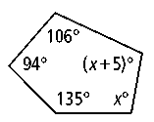

1. Solve for x, y, and z. (*3 points)*

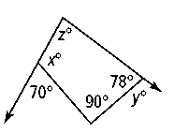

1. 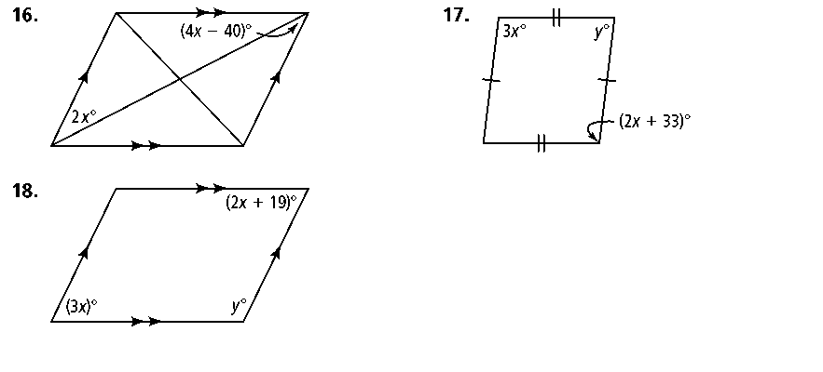Solve for x and y. (4 points)
2. 8. Solve for x and y. (4 points)

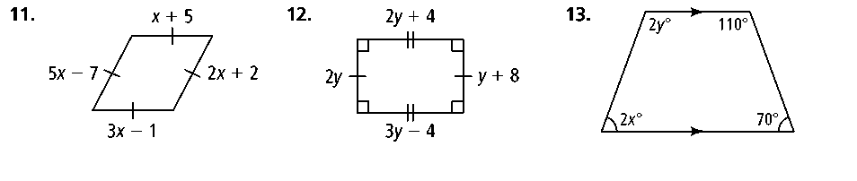

1. Solve for x and find the values of AD and EF. (3 points)

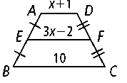

1. Solve for m<1 and m<2. (1 point)

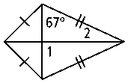

1. Determine m<1, m<2, m<3, and m<4. *(2 points)*

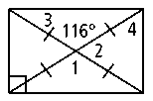

12. Determine m<1, m<2, m<3, and m<4. *(2 points)*

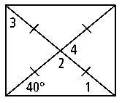

13. Solve for x and y in the parallelogram below. (4 points)

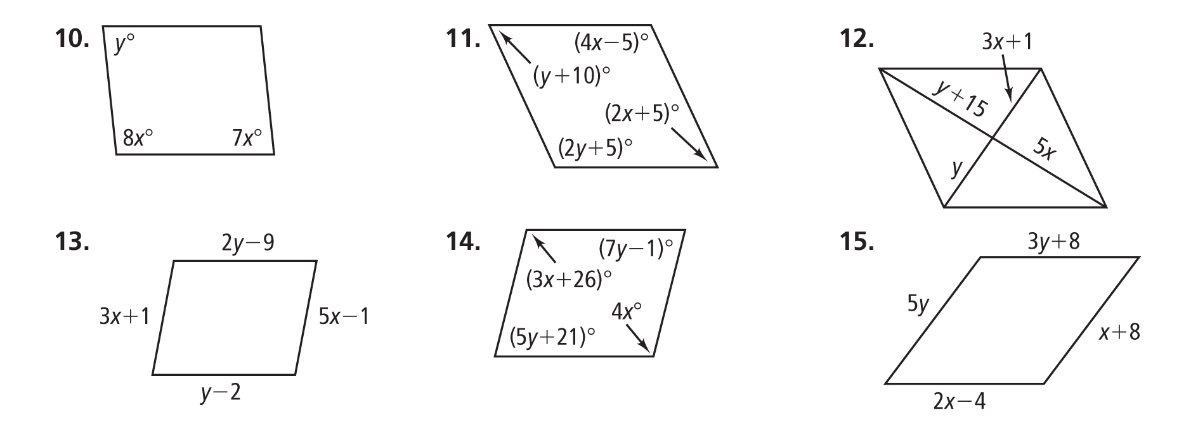

**14.** Determine what type of quadrilateral the following figure is using a mathematical argument. (*2 points for appropriate work in the workspace, 1 point for naming the quadrilateral, 2 points for correct explanation)*

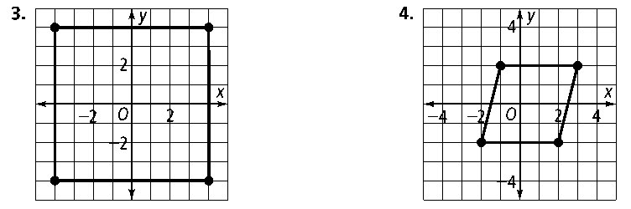

This quadrilateral is a ________________________ because I showed that ____________________________  
  
_________________________________________________________________________________________________________

using __________________________________________________________________________________________________

**16.** Graph the quadrilateral on the coordinate plane and determine the type of quadrilateral it is using a mathematical argument. (*1 point for graph, 2 points for appropriate work in the workspace, 1 point for naming the quadrilateral, 2 points for correct explanation)*

*A*(3, 5), *B*(6, 5), *C*(2, 1), *D*(1, 3)

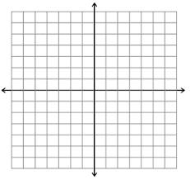

This quadrilateral is a ________________________ because I showed that ____________________________  
  
_________________________________________________________________________________________________________

using __________________________________________________________________________________________________

**17.** Graph the quadrilateral on the coordinate plane and determine the type of quadrilateral it is using a mathematical argument. (*1 point for graph, 2 points for appropriate work in the workspace, 1 point for naming the quadrilateral, 2 points for correct explanation)*

*A*(0, 3), *B*(5, 0), *C*(2, −5), *D*(−3, −2)



This quadrilateral is a ________________________ because I showed that ____________________________  
  
_________________________________________________________________________________________________________

using __________________________________________________________________________________________________